IMPARTIALITY POLICY
Prescient Security, LLC.
1900 Church Street, Suite 300,
Nashville, TN 37203
https://www.prescientsecurity.com
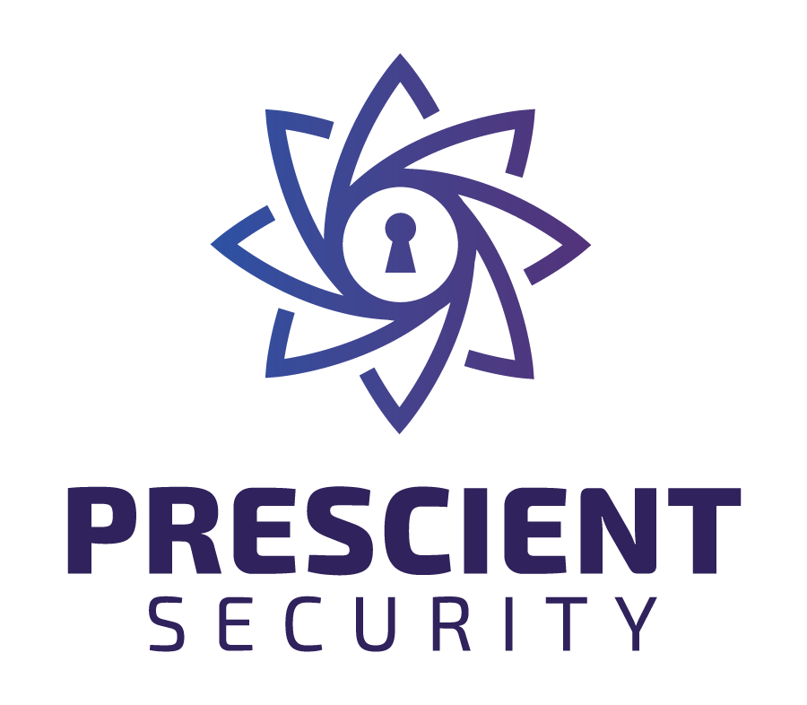
Prescient Security understands the importance of impartiality and potential conflicts of interest in carrying out its management system activities. At the core of Prescient Security’s Impartiality Policy is management’s commitment to maintaining independence, in fact, perception and removing threats to impartiality. Prescient Security defines threats as a relationship that threatens impartiality based on ownership, governance, management, personnel, shared resources, finances, contracts, marketing, and payment of a sales commission and/or other inducements for the referral of new clients.
Review and analysis of impartiality are conducted on an ongoing basis as well as annually with regards to all prospects, clients, and personnel to ensure all conflicts of interest and threats to impartiality are identified, reviewed, analyzed, resolved, and monitored. In addition, Prescient Security’s review process ensures that we do not perform audit services for clients where non-audit services have been performed and that ISO management consulting services are not performed by Prescient Security.
Prescient Security’s leadership ensures adherence to the impartiality policy through annual management reviews, automated monitoring tools, internal audits, and formal risk assessments of our audit processes.
Prescient Security operates under and complies with the independence requirements established by the American Institute of Certified Public Accountants, ISO/IEC 17021, ISO/IEC 17020, ISO/IEC 17025, ISO/IEC 17065, ISO/IEC 27006, ISO/IEC 27006-2, ISO/IEC 42006, ISO/IEC 27706, ISO/IEC 20000-6, FedRAMP and HITRUST and has developed this Impartiality Policy and supporting procedures to ensure ongoing compliance.
Prescient Security is the legal entity responsible for certification activities. Prescient Security, its Directors, Managers, employees and others involved in the certification of organizations fully understand the importance of impartiality in undertaking its Certification Activities. Prescient Security provides its services in an open, independent, and impartial manner to all clients and potential clients.
Prescient Security ensures it does not pose a risk to its impartiality in assessing systems that will potentially house U.S. federal information. Prescient Security ensures that all ownership, governance, personnel, finances, and payments for work align with all U.S. laws, policies, and regulations.
Prescient Security will therefore ensure that in its dealings with clients or potential clients, all employees or other personnel involved in certification/inspection/auditing activities are, and will remain, impartial.
Prescient Security and its personnel will ensure it does not engage in any activities that may conflict with their independence of judgement and integrity in relation to their inspection activities. In particular, they shall not be engaged in the design, manufacture, supply, installation, purchase, ownership, use or maintenance of the items inspected.
In accordance with ISO/IEC 17025:2018, Prescient Security ensures that it maintains independence from developers and their assets. Prescient Security maintains a list of all developers and their assets associated with the library. The list is reviewed and updated annually, or whenever there are changes. All personnel are responsible for signing F01, stating that they have no conflicts of interest with developers and their assets. Prescient Security ensures that it is organized to ensure that personnel involved in testing and evaluation are not involved in the development or maintenance of related systems. Clear separation of responsibilities is maintained to prevent any undue influence from developers.
In accordance with ISO /IEC 17065:2012, Prescient Security and any part of the same legal entity and entities will ensure that it is not:
- The designer, manufacturer, installer, distributor or maintainer of the certified product
- The designer, implementer, operator or maintainer of the certified process
- The designer, implementer, provider or maintainer of the certified service
- Offer or provide consultancy to its clients
- Offer or provide management system consultancy or internal auditing to its clients where the certification scheme requires the evaluation of the client’s management system
In accordance with ISO/IEC 42006:2025, Prescient Security and any part of the same legal entity and entities shall not:
- Offer or provide any consultancy related to Artificial Intelligence Management Systems (AIMS) to clients seeking or maintaining ISO/IEC 42001 certification.
- Offer or provide consultancy in information security management, data protection or privacy management, including but not limited to:
  - Data Protection Impact Assessments (DPIA)
  - External Data Protection Officer (DPO-as-a-service)
  - Data protection checks or privacy advisory activities
- Offer or provide consultancy related to organizational risk management, including development, implementation, or operation of risk management frameworks for ISO/IEC 42001 clients.
- Provide any activity that could influence the design, implementation, operation, or improvement of the client’s AIMS or related processes that are within the scope of ISO/IEC 42001 certification.
- Use personnel who have been involved in such consulting activities to perform audits, reviews, or certification decisions for ISO/IEC 42001 clients.

These restrictions ensure full compliance with ISO/IEC 42006:2025 clause 5.2.2.1 and maintain the impartiality, independence, and integrity of ISO/IEC 42001 certification activities.

Prescient Security ensures that activities of separate legal entities, with which Prescient Security or the legal entity of which it forms a part has relationships, do not compromise the impartiality of its certification activities.
To ensure that impartiality is both maintained and can be demonstrated, the following principles have been established:
- Prescient Security certificates are only issued following a review by an independent authorized and competent member of the management team (who has not been involved in the audit) to ensure that no interest shall predominate.
- Prescient Security does not offer (and has never offered) management system consultancy or any other form of consultancy to companies or individuals. This applies to any / all ISO standards.
- Prescient Security does not offer (and has never offered) an internal audit service to its certified clients.
- Prescient Security does not own or have any interest (financial or otherwise) in any other company that offers certification or management system consultancy services.
- Prescient Security does not have (and will not form) any relationships with companies who offer consultancy or other services that can be construed as having an impact on the certification services provided by Prescient Security.
- Any proposed relationship between Prescient Security and any other company will undergo a risk assessment by the Working Group for Impartiality prior to that relationship being formalized. Any current relationships with companies, organizations and individuals will be risk assessed on a regular basis to ensure that the relationship does not impact upon the impartiality of the certification process.
- Individuals employed by or otherwise contracted to Prescient Security are required to document and record their current and past relationships with all companies. Any situation, past or present, which may present a potential conflict of interest is required by Prescient Security to be declared. Prescient Security will use the information to identify any threats to impartiality and will not use that individual in any capacity unless they can demonstrate that there is no conflict of interest.
- Prescient Security will not allocate a member of staff or subcontractor to a management system audit where any past relationship has existed. Exceptionally, and at the discretion of Impartiality Risk Group, an individual or subcontractor may be allocated to a management system audit where a past relationship has existed but there has been no relationship for a minimum of 2 years.
- Prescient Security does not and will not offer any commission, (“finders fees” or other inducements) to any individual or company in respect of referrals of clients unless:
  - The terms and conditions of any such referral are clearly established and can be demonstrated, and it can also be demonstrated that the fee is for a referral and the fact that a commission has been paid will in no way affect the outcome of an audit.
  - A risk assessment (to establish the potential for an unacceptable threat to impartiality) has been carried out in the process through which any such payment is made to an individual or organization (normally a consultant) requesting a commission for referrals.
  - All such payments are documented, recorded, and traceable and accompanied by a purchase order and invoice.
- Prescient Security does not offer specific training to any company with respect to implementing a particular ISO standard for that company. Any training offered by Prescient Security is general in nature and available to all companies or individuals who wish to attend.
- Prescient Security will ensure that it is not linked or marketed in any way, which links it with the activities of a management system consultancy and will take appropriate action should any such link be identified. Prescient Security ensures that it will not imply that certification would be simpler, easier, faster or less expensive if a specified consultancy organization were used.
- Auditors and others involved in the certification process are not and will not be put under any pressure and will not be influenced in any way to come to a particular conclusion regarding the result of an audit. All personnel are responsible for signing F01, stating that they have no conflicts of interest with their assigned activities.
- Prescient Security does not and will not provide internal information security reviews of its client’s ISMS subject to certification. Prescient Security shall be independent from the body or bodies (including any individuals) which provide the internal ISMS audit.
- The Impartiality Policy is published at https://prescientsecurity.com/impartiality
- Prescient Security shall not be used to review or make a certification decision for a product for which they have provided consultancy for a period of two years.

